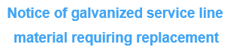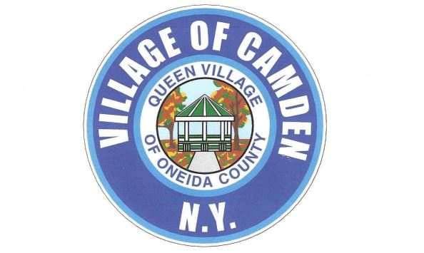

Dear Valued Consumer,

We are focused on delivering clean drinking water and protecting the consumers of every household in our community. This notice contains important information about your drinking water service connection. Please read completely and share this information with anyone who consumes food or drinks water at this property.

We have determined that the pipe (also referred to as a service line) delivering water from the water main to the building on this property is made from a galvanized material and may have absorbed lead. Our records indicate that a lead service line or lead fittings may have been present in the past, leading to this classification. EPA has defined these types of lines as "galvanized requiring replacement." The figure below provides a visual representation of the service line. Please note, this is not a true representation of your service line, but an example of a common scenario.

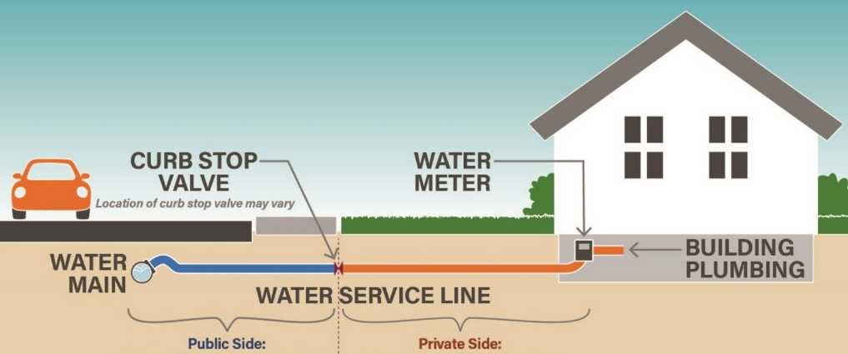

Galvanized service lines that have absorbed lead can contribute to lead in the drinking water. People living in homes with a galvanized service line that has absorbed lead may have an increased risk of exposure to lead from their drinking water.

Health effects of lead

Exposure to lead in drinking water can cause serious health effects in all age groups. Infants and children can have decreases in IQ and attention span. Lead exposure can lead to new learning and behavior problems or worsen problems. The children of women who are exposed to lead before or during pregnancy can have an increased risk of these negative health effects. Adults can have increased risk of heart disease, high blood pressure, and kidney, or nervous system problems.

Steps you can take to reduce the risk of lead in drinking water

Below are recommended actions you may take, separately or in combination, if you are concerned about lead exposure from your drinking water. This list also includes where you may find more information and is not intended to be a complete list or to imply that all actions equally reduce lead in drinking water.

**Use a water filter certified to remove lead.** Using a filter can reduce lead in drinking water. If you use a filter, it should be certified to remove lead. Read instructions provided with the filter thoroughly to ensure correct installation, maintenance and replacement timeframe. Using a cartridge after it has expired can reduce its effectiveness.

**Clean your faucet aerator.** Regularly remove and clean your faucet's screen, also known as an aerator. Sediment, debris and lead particles can collect in your aerator. Regular cleaning ensures these particles are cleaned and removed.

**Use cold water.** Do not use hot water from the tap for drinking, cooking or making baby formula as lead dissolves more easily into hot water. Boiling water does not remove lead from water.

**Run your water.** The more time water has been sitting in the pipes providing water to your home, the more likely it is to contain lead. Before drinking, flush your home's pipes by running the tap, taking a shower or doing laundry. The amount of time to run the water will depend on your service line material, as well as the length and diameter of the service line and the amount of plumbing in your home.

Get your child tested to determine the lead levels in their blood

A family doctor or pediatrician can perform a blood test to determine lead levels. They will also be able to provide more information about the health effects of lead. State, city or county health departments can also provide more information about how you can have your child's blood tested for lead. The Centers for Disease Control and Prevention recommends public health actions when the level of lead in the child's blood is 3.5 micrograms per deciliter or more. For more information, and links to the CDC's website, please visit https://www.epa.gov/ground-water-and-drinking-water/basic-information-about-lead-drinking-water

Replacing galvanized service lines

**If you are planning construction or to replace the portion of the service line you own, please email us at** [**Camdendpw245@yahoo.com**](mailto:Camdendpw245@yahoo.com) **OR call us (315)245-0560**

For questions regarding your service, please contact us at **Camdendpw245@yahoo.com**

**This notice is being sent to you by: The Village of Camden**

**State Water System ID: NY3202385**

**Date Notice Distributed: 11/1/2024**